The Chiswick Book Festival Quiz – by Gary Wigglesworth
Round 1 – 10 questions on Chiswick Book Festival authors and famous authors from the Chiswick Writers Trail
1 Reverend Richard Coles is appearing at the Chiswick Book Festival on September 10th. His first non-fiction book is called ‘Murder Before…’ what?
A)
2 Which playwright, who lived in Chiswick in the 50’s and 60’s, has a theatre in London’s West End named after him?
A)
3 Which Patrick Hamilton (one time Chiswick resident) play was filmed by Alfred Hitchcock?
A)
4 Cressida Cowell (at the Festival on September 10th) recently ended her reign as the Waterstones Children’s Laureate. Can you name the author and poet who replaced her?
A)
5 E.M. Forster was a Chiswick resident in the 40’s and 50’s – in which fictional best seller, published in 2021, does he appear in as minor character?
A)
6 The actor Kevin McNally (local authors party – September 7th) is talking about his new science fiction book ‘Sons of Sol’. Can you name the legendary comedian he has portrayed on Radio 4, beginning in 2014?
A)
7 Children’s author Rob Biddulph appears at the Festival on September 17th – can you name the classic children’s character (from 1964) he has been illustrating since 2017?
A)
8 J.G. Ballard, who lived in Chiswick in the 1950’s, was shortlisted for the Booker prize in 1994 for which of his books? It was later filmed by Stephen Spielberg.
A)
9 Dame Eileen Atkins (appearing at the Festival on September 8th) is also a screenwriter – can you name the Virginia Woolf novel she adapted for film in 1997?
A)
10 Caroline Frost and Robert Ross are at the Festival on September 10th to celebrate which long running series of British comedy films?
A)
Round 2 - The clue is in the question – can you unravel the anagram to solve the clue? The first 5 are titles of Modern Classics, the next 5 are author names. (1 point)
1 Could it be argued - the fact that the titular character lives in West EGG BETRAYS THAT he is nouveau riche?
A)
2 At one point in this terrifying horror set at the Outlook Hotel, Jack Torrance attempts to get to his wife Wendy by knocking the door off its THIN HINGES
A)
3 Once the plot is in place the characters in this book would raise an ALARM IF MAN was spotted approaching.
A)
4 On the streets SIT THESE DOUR rebels in this coming of age classic written when the author was just seventeen.
A)
5 Is it easy to see how the victim in this novel could be so ENTHRALLED YET PERMIT the titular character to murder him.
A)
6 It could be argued that no other author has written of TEENS WOUNDS as sharply or as comically as this English author.
A)
7 Some of the more rough and ready characters created by this Scottish author drink until their LIVERS WHINE.
A)
8 This American author, with his lengthy award-winning novels could not be accused as one who might SAVOR FACILE TWADDLE (American spelling of savour!).
A)
9 An English satirical author of high paced bawdy farces - not to be recommended to a reader who HATE ROMPS.
A)
10 This Scottish born author wrote some all-time classics – including the occasionally STERN BOISTEROUS NOVEL.
A)
Round 3 – 1-star reviews. These are 1-star reviews from a certain online retailer, but which book are they not happy about? (Please note: reviews are copied verbatim; spelling, grammar and thoughts are reviewers’ own). Circle the correct answer for a point.
1 ‘In this story females are for breeding and nothing else. There are no meaningful female characters. Even in the 70s when this book was written this approach lacked relevance’. Is it: A) Riders by Jilly Cooper B) The Handmaids Tale by Margaret Atwood or C) Watership Down by Richard Adams?
2 ‘Crammed with the nonsensical mind talk of a confused butler which became too much for me to tolerate’ Is it: A) Right Ho, Jeeves by PG Wodehouse B) The Remains of the Day by Kazuo Ishiguro or C) Gone with the Wind by Margaret Mitchell?
3 ‘Could not understand a word!! Shame because I loved the film’ Is it: A) A Clockwork Orange by Anthony Burgess B) Trainspotting by Irvine Welsh or C) Finnegan’s Wake by James Joyce?
4 ‘I got to page 22… there isn’t a Waitrose in Tunbridge Wells. I stopped. I’m trying again but a few pages past page 22 and there isn’t a Virgin Active in Tunbridge Wells either. I suggest Google for fact checking. Fact checking probably important for a murder enquiry. It may not matter to the plot but it’s really annoying and distracting and I don’t even live in Tunbridge Wells’. Is it: A) The Thursday Murder Club by Richard Osman B) The Remorseful Day by Colin Dexter or C) Cover her Face by P.D James?
5 ’About a boy who gets into crime and blames others when he gets caught… Said a bloke with a dog made him do it’ Is it: A) Oliver Twist by Charles Dickens B) The Curious Incident of the Dog in the Night-time by Mark Haddon or C) The Wasp Factory by Iain Banks?
6 ‘Awful book and a total waste of money… If you want to read some self help tips for free hit Google and then draw a stick man whilst you’re at it. You’ll have written the book yourself within 5 minutes and saved £8.50’. Is it: A) Reasons to Stay Alive by Matt Haig B) The Boy, the Mole, the Fox and the Horse by Charles Mackesy or C) Happy: Finding Joy in Every Day and Letting Go of Perfect by Fearne Cotton
7 ‘found myself reading other books just so I had an excuse not to continue reading this one. In the end all I can say to truly show how I feel about this novel is that this book BORED me. 177 pages of art that is 'quite useless'. Is it: A) The Goldfinch by Donna Tartt B) The Picture of Dorian Gray by Oscar Wilde or C) The Girl with the Pearl Earring by Tracy Chevalier
8 ‘Read many contrasting reviews but decided to give it a go as I love historical fiction. A Man Booker prize winner could not that be bad. I was so wrong. The book is almost unreadable. He said, he said and he said…and on it goes. Who the hell is HE? Which he when there are three men in the conversation? 100% shocked by how bad the writing is. Just don’t bother’. Is it: A) Heat and Dust by Ruth Prawer Jhabvala B) The Luminaries by Eleanor Catton or C) Wolf Hall by Hilary Mantel.
9 ‘i read this book because all my freinds where saying how cool it was, but really it was rubbish!!! i mean i like fantasy but this book was so derivitive!!! not to mention wordy... i think people just think its 'a classic' because its really old and really long, but actually it stinks!!! If you want good fantasy try the Warhammer books, those have elves and dwarves and stuff in but at least there not boring!!!!’ Is it A) The Hobbit by JRR Tolkien B) A Game of Thrones by George RR Martin or C) Rumpelstiltskin by the Brothers Grimm?
10 ‘this book was so boring that half way through, i could have cheerfully drowned the boy and fed the sticky bits to the tiger...tedious in the extreme’ Is it A) The Jungle Book by Rudyard Kipling B) Life of Pi by Yann Martell or C) The White Tiger by Aravind Adiga?
Round 4 – Literature links and lists – novel conundrums!
1 What connects Endeavour, Jane, Jules and Philip?
A)
2 What food stuff connects books by William Boyd, Dorothy Koomson and Brian Moore?
A)
3 Which 1851 novel connects DJ Richard Melville Hall, Starbucks and Ray Bradbury?
A)
4 What is the Christian name of crime writers Robinson, May, Lovesey and James?
A)
5 Which author’s work has inspired songs by Led Zeppelin, Rush, Enya and Star Trek actor Leonard Nimoy?
A)
6 What specifically connects these authors: Booth Tarkington, William Faulkner, John Updike and Colson Whitehead?
A)
7 What links the surnames of the authors of, White Fang, The Miniaturist and The Time Machine?
A)
8 What surname is shared by authors with the first initials ER (born 1875) WS (born 1914) and A (born 1965)?
A)
9 What profession follows Rogue for John Grisham, Family for James Patteson and Lincoln for Michael Connelly?
A)
10 Who completes this list? Boggis, Bunce and ?
A)
Round 5 – Bad Cover Versions
Below, I’ve drawn the covers of 9 books - 3 begin with C, 3 with B and 3 with F (Chiswick Book Festival). Name the book and the author and get a point for each. Just write your answer against the numbers of the images on the next page.
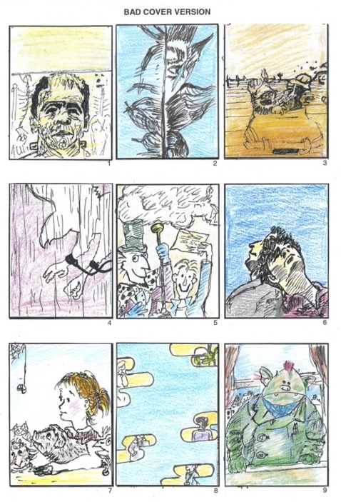

Round 5 – Bad Cover Versions
1.
2.
3.
4.
5.
6.
7.
8.
9.

Once completed, please fill in your name, email address and phone number and email the document to admin@chiswickbookfestival.net by midnight on Sunday September 25th, putting ‘Quiz’ in the subject box. Please make a donation to one of our charities if you wish.
The prize will be a fine edition of a book written by one of the Chiswick authors in Round 1, donated by Stephen Foster of Foster Books in Chiswick High Road.

Your name:
Your email address:
Your phone number:
If you are choosing to support a charity, please say which one:
If you’ve enjoyed the quiz, please check out The Book Lover’s Quiz Book website https://www.gpwigglesworth.co.uk/ or @gpwigglesworth on Twitter or Instagram. Gary runs a monthly book quiz at The Betsey Trotwood in Farringdon (details on website).
‘The Book Lover’s Quiz Book’ is available now from all good book suppliers!

